July 2009

WWW.RADIOZEILEN.NL/marblehead

Open Dutch Championship
Radio Marblehead class
2009

September 25, 26 and 27 2009

Location: Gravenbroekseplas in Reeuwijk,
Notaris d’Aumerielaan 35
2811 HS Reeuwijk
Nederland

Organised by the “Roei en Zeilvereniging “Gouda”,
in coöperation with KOM (Dutch Class Organisation Marblehead)

Correspondence: Chris Vaes, Galigaanstraat 33, 5247 HM Rosmalen
Telephone: home, +31 (0)73 5117796 Mobile, +31 6-23420516
E-mail: chris.vaes@zonnet.nl

NOTICE OF RACE

OPEN DUTCH CHAMPIONSHIP RADIO MARBLEHEAD CLASS
1 | RULES
1.1 | The regatta will be governed by the rules as defined in The Racing Rules of Sailing  2009 - 2012.
1.2 | The prescriptions of the Royal Dutch Yachting Association will apply .
1.3 | The ‘Rules for Championships Sailing and Windsurfing’ will apply.
1.6 | If there is a conflict between languages the English text will take precedence.
3 | ELIGIBILITY AND ENTRY
3.1 | The regatta is open to all boats of the MARBLEHEAD class.
3.2 | Eligible boats may enter by completing the attached entry form and sending it, together with the required fee, to Chris Vaes, Galigaanstraat 33, 5247 HM Rosmalen or by e-mail chris.vaes@zonnet.nl  Banking: NeMoZo, 1213 XV , Waldecklaan 17, Hilversum, Netherlands  Ingbank 4616409 (NEW Bank number)  International: IBAN NL72 INGB 0004616409 BIC INGBNL2A
4 | CLASSIFICATION  The ISAF Sailor Classification Code will apply.
5 | FEES
5.1 | Required fees are as follows:  Class Fee  M € 30,-
5.2 | Other fees:  Sailors Dinner € 20,- p.p. Saterday evening 18.30 hours (minimum 25 entrees)
6 | QUALIFYING SERIES AND FINAL SERIES  The regatta will be carried out in accordance with the Heat Management System 2006, ISAF - . RSD.
7 | SCHEDULE
7.1 | Registration:  Day and date _Friday 25 september 2009  From 9.00 hour To 10.00 hours
7.3 | Dates of racing:  Date Class _M____  _25-09-2009____ racing from 10.30 to 17.00  _26-09-2009____ racing from 10.30 to 17.00  _27-09-2009____ racing from 10.00 to 15.00  No warning signal wil be given after 15.15, if therefore the last race cannot be completed this race will be abanded. Prizegiving at 16.00 or soon thereafter
7.4 | Number of races:  Class Races per day  _M___ _10___
7.5 | The scheduled time of the warning signal for the first race is Friday _10.30_, Saturday _10.30_, Sunday _10.00_.
8 | MEASUREMENTS  Each boat shall produce a valid measurement certificate.
9 | SAILING INSTRUCTIONS  The sailing instructions will be available after registration on 25-10-2009 at 9.00 .
10 | VENUE
10.1 | Attachment A shows the location of the regatta harbour.
11 | THE COURSES  The courses to be sailed will be noticed upon the courseboard
12 | PENALTY SYSTEM
12.1 | For the _M__ class rules 44.1 and 44.2 are changed so that only one turn, including one tack and one gybe, is required.
 | Protestforms will be available at the race office
12.2 | Decisions of the protest committee will be final as provided in rule 70.4.
13 | SCORING
13.1 | Four races are required to be completed to constitute a series.
13.2 | (a) When fewer than 5 races have been completed, a boat’s series score will be the total of her race scores.
 | (b) When from 4 to 9 races have been completed, a boat’s series score will be the total of her race scores excluding her worst score.
 | (c) When 10 to 18 races have been completed, a boat’s series score will be the total of her race scores excluding her two worst scores.
 | (d) After 19 races another score shall be excluded for every further 9 races completed
15 | BERTHING  Boats shall be kept in their assigned places in the [boat park] [harbour].
19 | PRIZES  Prizes will be given as follows: _1st , 2nd and 3rd  For the winner there is also the Dutch Championship flag from the Dutch Sailing Organisation and for the best Dutch sailor there is the KOM wisseltrofee  Participation awards will be given to all competitors
20 | DISCLAIMER OF LIABILITY  Competitors participate in the regatta entirely at their own risk. See rule 4, Decision to Race. The organizing authority will not accept any liability for material damage or personal injury or death sustained in conjunction with or prior to, during, or after the regatta.
22 | FURTHER INFORMATION  For further information please contact _Chris Vaes chris.vaes@zonnet.nl +31 73 5117796  or Paul d´Arnaud. paul.darnaud@hetnet.nl +31 35 685 0504

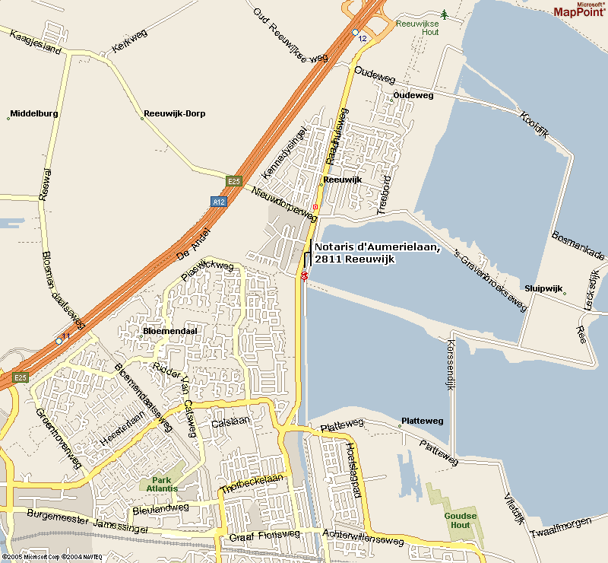

Location:

Reeuwijk

near

Gouda

between

Rotterdam

and

Utrecht


Entry form for Radio Sailing

Information
Evenent: Dutch Open Championship Radio MARBLEHEAD CLASS
Dates: September 25, 26 and 27 2009
Organization: Roei en Zeilvereniging Gouda in cooperation with NEMOZO
Submit your entry to: Chris Vaes, Galigaanstraat 33, 5247 HM Rosmalen or by e-mail chris.vaes@zonnet.nl

Competitor

Name:
Adress:
Areacode, City and Country:
Telephone by day / evening:
Member of Sailing club: Membership card National Authority:

Boat

Registration number: Sail nummer:
Name of the boot:
Frequency: ……….. ………… …………. …………. …………. ………….

Fee: €. 30,- Sailors Dinner: ….. x € 20.- = Total: € …………………

Transfer your entry fee to: KOM , 1213 XV , Waldecklaan 17, Hilversum, Netherlands

Ingbank 4616409 (NEW Bank number)

International: IBAN NL72 INGB 0004616409 BIC INGBNL2A

By sending this formular, the signer declared his membership of his National Authority and acceptation of the rules for modelsailing according to the Racing Rules of Sailing 2005-2008 of the ISAF.
Registration to the Competetors list followed by receiving the Fee, as mentioned above, before September 13th 2008

Attending the races will be on own risk. The race comity will not be responsible for any damage on ship, equipment or person, as a consequence of attending the race.

Date: Signature:
_

